ML Pipelines
Teaching Notes
Bundling Feature Engineering, Missing-Data Handling, and a Model into One Object

Contents
Contents 2
1. The Problem a Pipeline Solves 3
2. Build a Model the Normal Way First 3
Step 1: Engineer, Impute, Encode, Train 3
Step 2 and 3: Tune, Then Select 3
3. What a Pipeline Actually Is 4
4. Packaging the Selected Model 5
5. Adding Feature Engineering, No Custom Class Required 5
A Subtle but Important Detail: Order 6
6. Tuning a Pipeline Directly 6
7. Practical Guidance 6
Summary Cheat Sheet 7
What a Pipeline Is 7
Building Blocks Used Here 7
Tuning 7
The One Thing to Verify 7

1. The Problem a Pipeline Solves
Building a model normally means several separate preprocessing steps before the model itself ever sees the data: engineer a feature, fill in missing values, encode categorical columns. Each of those steps has to be repeated, in the exact same way, every single time the model is used again, whether that's during cross-validation, or months later when a new batch of raw customer applications needs a prediction. Nothing stops someone from forgetting a step, doing it slightly differently, or applying it in the wrong order.
A `Pipeline` fixes this by bundling every preprocessing step and the model itself into a single object. That object has one `.fit()` and one `.predict()`, call either one, and every step underneath runs automatically, in the right order, every time.
Pipeline = preprocessing steps + a model, wrapped as one object

2. Build a Model the Normal Way First
This case study uses the same credit-default dataset as the `Decision Trees` case study, with missing values deliberately added to two numeric columns (`Credit_Amount`, `Age`) and two categorical columns (`Savings_Acc`, `Job`), so the whole workflow has something real to handle.
The right way to learn pipelines is to build a model the traditional way first, and only package it into a pipeline afterward. Doing it in the other order teaches the mechanics of `Pipeline` without ever explaining why each step is there.

Step 1: Engineer, Impute, Encode, Train
- Engineer a simple ratio feature: Amount_per_Month = Credit_Amount / Duration_in_Months.
- Fill missing numeric values with the median, missing categorical values with the mode (most frequent value).
- One-hot encode the categorical columns with pd.get_dummies.
- Train an unrestricted Decision Tree on the result.

Step 2 and 3: Tune, Then Select
GridSearchCV searches over max_depth and min_samples_leaf, scored by recall, and grid_search.best_estimator_ is the model actually selected.
Figure 1 — Recall before tuning, after tuning, and after packaging into a pipeline.
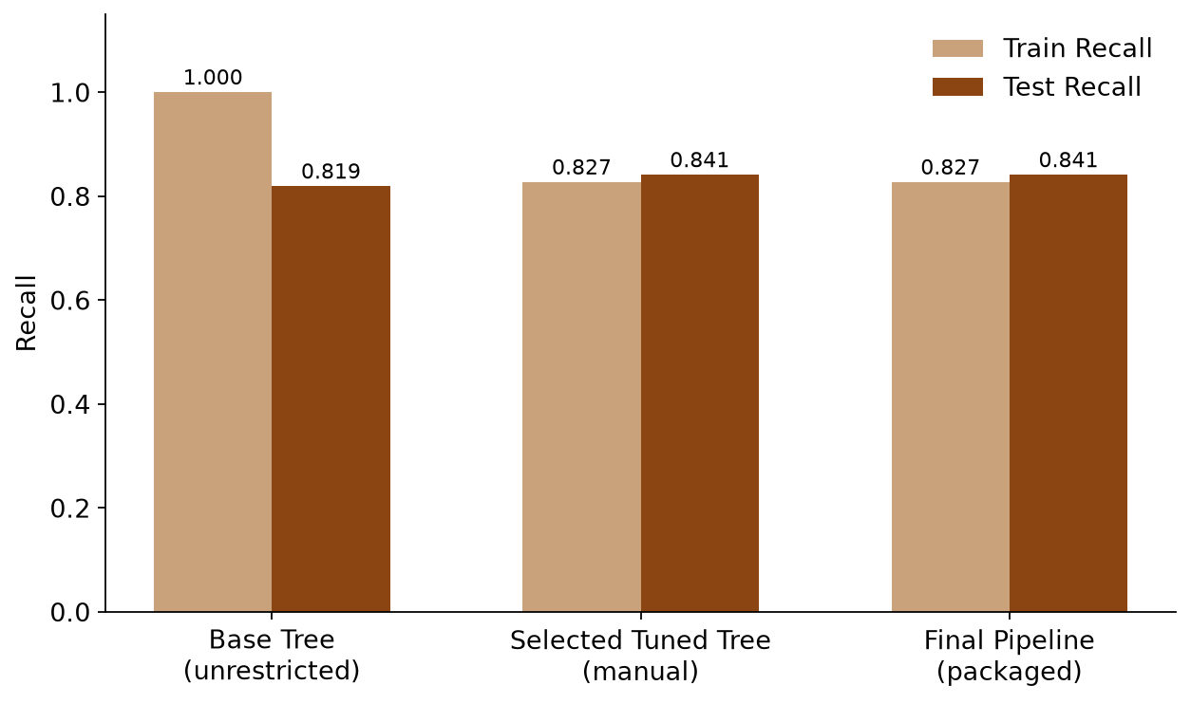
The unrestricted base tree reaches 100% train recall but only 81.9% test recall, a large gap, the classic sign of overfitting: the tree has memorised quirks of the training rows that don't hold up on new data. Tuning to max_depth=7, min_samples_leaf=5 gives up a little training recall (82.7%) in exchange for a smaller, more trustworthy gap, and even slightly better test recall (84.1%). That tuned tree is the one actually selected for deployment.

3. What a Pipeline Actually Is
A Pipeline is not a new algorithm, it's a container. It holds a list of steps, and it knows one rule: every step except the last must be a transformer (something with .fit() and .transform()), and the last step is the actual model (something with .fit() and .predict()).
make_pipeline(step_1, step_2, ..., model) builds this container and names each step automatically from its class name in lowercase. When you call pipeline.fit(X, y), it runs every transformer's fit_transform() in order, then fits the final model on whatever comes out the other end. When you call pipeline.predict(X_new), it runs every transformer's transform() in the same order (no re-fitting), then asks the model to predict.
Figure 2 — The final pipeline built in this case study, as one chain of steps.
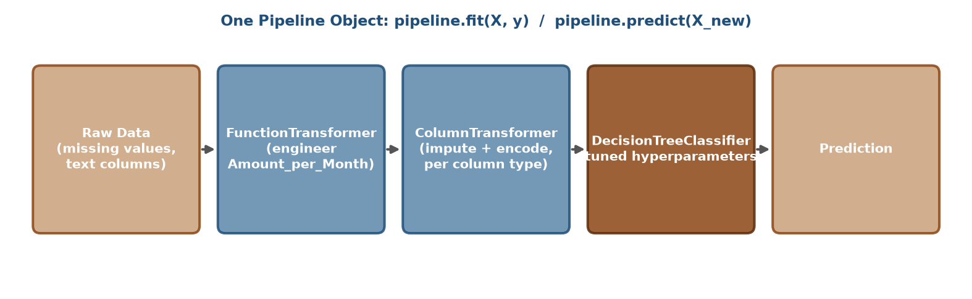

4. Packaging the Selected Model
Once a model is selected, the encoding and imputation logic gets rebuilt as pipeline steps, not as one-off pandas code. Different column types need different treatment, so a ColumnTransformer routes each group of columns to its own small pipeline:
Column Type | Steps Applied | Why
Categorical (Savings_Acc, Job, ...) | SimpleImputer (most frequent) then OneHotEncoder | Fill missing category, then turn text into numbers
Numeric (Credit_Amount, Age, ...) | SimpleImputer (median) | Fill missing value; no encoding needed

The ColumnTransformer sits inside the outer pipeline, alongside the tuned DecisionTreeClassifier (built with the exact hyperparameters GridSearchCV selected):
final_pipeline = make_pipeline(preprocessor, DecisionTreeClassifier(**grid_search.best_params_))
Fit directly on the raw, un-engineered, un-imputed, un-encoded data, this pipeline reproduces the selected model's result exactly: 82.7% train recall, 84.1% test recall, the same numbers as Figure 1's middle bars. Packaging the model changed nothing about what it predicts.

5. Adding Feature Engineering, No Custom Class Required
The Amount_per_Month ratio needs to happen inside the pipeline too, for the same reason as imputation and encoding: anyone using this pipeline on new data shouldn't have to remember to compute that ratio by hand first.
A full custom transformer (a Python class with .fit() and .transform() methods) is one way to do this, but it's more machinery than a simple, stateless calculation needs. FunctionTransformer is the lighter option: hand it any ordinary function, and it wraps that function so the pipeline can call it like any other step:
feature_engineering = FunctionTransformer(add_amount_per_month)
add_amount_per_month here is just a plain function that takes a dataframe in and returns a dataframe with one new column, nothing pipeline-specific about it at all. FunctionTransformer is the adapter that lets an ordinary function sit inside a pipeline.

A Subtle but Important Detail: Order
The ratio is computed before imputing, on the raw (possibly missing) Credit_Amount and Duration_in_Months, in both the manual version and the pipeline. That means Amount_per_Month itself can come out missing, and gets imputed downstream exactly like any other numeric column. Getting this order backwards between the manual build and the pipeline (say, imputing first and engineering second in one but not the other) would silently produce different numbers, exactly the class of mismatch a pipeline exists to prevent. Confirming the pipeline reproduces the manually-built model's numbers exactly is how that was checked here, not assumed.

6. Tuning a Pipeline Directly
This case study tuned the plain DecisionTreeClassifier first, then packaged the winning hyperparameters into the pipeline afterward. GridSearchCV can also tune a pipeline directly, which is useful when preprocessing choices themselves should be searched over, not just model hyperparameters.
Parameters are addressed as step_name__parameter, using the same lowercase-class-name that make_pipeline assigns automatically:
param_grid = {"decisiontreeclassifier__max_depth": [3, 4, 5, 6, 7]}
Searching this way has one advantage the two-stage approach in this case study doesn't: every candidate hyperparameter combination is tested with the preprocessing refit fresh inside every cross-validation fold, rather than fit once outside of it. For a stateless step like the ratio feature or a fixed OneHotEncoder that makes no difference, but for anything that learns from data (an imputer's median, a scaler's mean), tuning the whole pipeline this way is the safer default in general, even though it wasn't necessary to change the result in this particular case study.

7. Practical Guidance
- Build and tune a model the normal way first. Understand what it needs before packaging it, packaging is not a substitute for the modeling decision.
- Use FunctionTransformer for simple, stateless feature engineering; reach for a custom class only when a step needs to learn something from training data that a built-in transformer doesn't already provide.
- Keep the order of operations identical between any manual prototype and the final pipeline, then prove it with matching numbers, don't assume it.
- Route different column types to different preprocessing using ColumnTransformer, one sub-pipeline per column group.
- Prefer tuning the whole pipeline with GridSearchCV over tuning the model alone, especially once any step in the pipeline learns something from training data.

Summary Cheat Sheet

What a Pipeline Is
- A single object chaining transformers (steps with fit/transform) and a final model (fit/predict).
- make_pipeline(...) auto-names each step from its class name, lowercased.

Building Blocks Used Here
- FunctionTransformer(your_function) — wraps a plain function as a pipeline step, no class needed.
- SimpleImputer(strategy=...) — fills missing values ("median", "most_frequent", etc.).
- OneHotEncoder(drop="first") — turns categorical columns into 0/1 columns.
- ColumnTransformer([...]) — routes different columns to different preprocessing.

Tuning
- Address a pipeline step's parameter as stepname__parameter in a GridSearchCV param_grid.
- Tuning the whole pipeline (not just the model) keeps every fold's preprocessing fit fresh.

The One Thing to Verify
- A packaged pipeline should reproduce the manually-built, selected model's numbers exactly, confirm this, don't assume it.

